*Florida International University*

*School of Computing and Information Sciences*

Software Engineering Focus

Feature Document

User Story #**149**

**Team Member: Justin Alvarez**

….

**Product Owner(s)**:

….

**Mentor(s)**:

…..

**Instructor**: Masoud Sadjadi

**User Story** Learning nanogui - part 2

* As a developer, I want to thoroughly understand nanogui so I can make a more expressive and better designed application.

Acceptance Criteria

* I can understand the more complex examples on their github
* I can make my own test application that looks like a skeleton of a real application
* I understand what different kinds of widgets are available

**Use Case** #**.... – Title**

**Use Case Diagram**

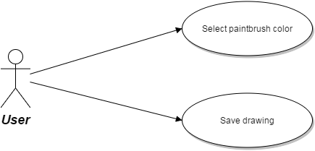

**Sequence Diagram**

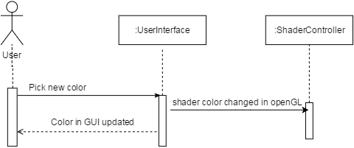

**Class Diagram**

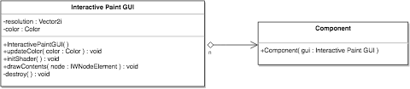

**Unit Test**

**Integration Test**

**Visual User Guide**